**Objective questions**

1. **What is the distribution of account balance across different regions?**

To find the distribution of account balances across different regions:

**SQL QUERY**

SELECT

g.GeographyLocation AS Region,

COUNT(bc.CustomerId) AS Num_Customers,

AVG(bc.Balance) AS Avg_Balance

FROM

bank_churn bc

JOIN

customerinfo ci ON bc.CustomerId = ci.CustomerId

JOIN

geography g ON ci.GeographyID = g.GeographyID

GROUP BY

g.GeographyLocation;

**RESULT**

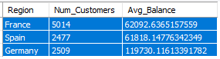

1. **Identify the top 5 customers with the highest Estimated Salary in the last quarter of the year.**

**SQL QUERY**

SELECT

CustomerId,

Surname,

EstimatedSalary

FROM

customerinfo

WHERE

EXTRACT(MONTH FROM 'Bank DOJ') IN (10, 11, 12)

ORDER BY

EstimatedSalary DESC

LIMIT 5;

1. **Calculate the average number of products used by customers who have a credit card.**

The average number of products used by customers who have a credit card is approximately 1.53.

**SQL QUERY**

Select avg(bc.NumOfProducts) as AvgNumofProductsWithCreditCard

From bank_churn bc

Join creditcard cc On bc.HasCrCard = cc.CreditID

Where cc.CreditID = 1;

1. **Determine the churn rate by gender for the most recent year in the dataset.**

This analysis examines customer churn rate segmented by gender (male/female) for the most recent year (using a Bank DOJ slicer). A calculated measure

ExitRate = [Total Exit Customers]*100/[Total Customers]

Interact with the Gender slicer to view churn rates specifically for male or female customers within the selected year.

This provides insights into potential gender disparities in churn rates. Consider including a chart for better visualization.

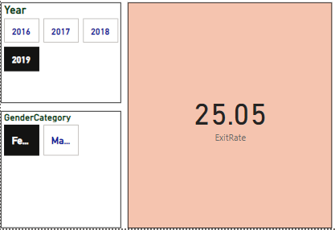

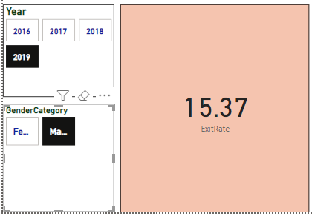

1. **Compare the average credit score of customers who have exited and those who remain.**

**SQL QUERY**

SELECT

AVG(CASE WHEN bc.Exited = 1 THEN bc.CreditScore ELSE NULL END) AS AvgCreditScoreExited,

AVG(CASE WHEN bc.Exited = 0 THEN bc.CreditScore ELSE NULL END) AS AvgCreditScoreRemain

FROM

bank_churn bc;

**RESULT**



1. **Which gender has a higher average estimated salary, and how does it relate to the number of active accounts?**

The average estimated salary for females is approximately 100,602, while for males, it is approximately 99,665. Despite the slightly higher average salary for females, males have more active accounts, with approximately 2,867 active accounts compared to 2,284 for females. This suggests that while females may have a higher average salary, males tend to have more active accounts.

**SQL QUERY**

SELECT

g.GenderCategory AS Gender,

AVG(ci.EstimatedSalary) AS AvgEstimatedSalary,

COUNT(CASE WHEN bc.IsActiveMember = 1 THEN ci.CustomerId END) AS NumActiveAccounts

FROM

customerinfo ci

JOIN

gender g ON ci.GenderID = g.GenderId

JOIN

bank_churn bc ON ci.CustomerId = bc.CustomerId

GROUP BY

g.GenderCategory;

**RESULT**



1. **Segment the customers based on their credit score and identify the segment with the highest exit rate.**

The segment with the highest exit rate is "Poor," with an exit rate of approximately 22.02%. This suggests that customers with poor credit scores are more likely to churn compared to customers in other credit score segments.

**SQL QUERY**

SELECT

Segment,

AVG(Exited) AS ExitRate

FROM (

SELECT

CASE

WHEN CreditScore BETWEEN 800 AND 850 THEN 'Excellent'

WHEN CreditScore BETWEEN 740 AND 799 THEN 'Very Good'

WHEN CreditScore BETWEEN 670 AND 739 THEN 'Good'

WHEN CreditScore BETWEEN 580 AND 669 THEN 'Fair'

WHEN CreditScore BETWEEN 300 AND 579 THEN 'Poor'

ELSE 'Unknown'

END AS Segment,

Exited

FROM

bank_churn

) AS SegmentedCustomers

GROUP BY

Segment

ORDER BY

ExitRate DESC;

**RESULT**

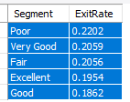

1. **Find out which geographic region has the highest number of active customers with a tenure greater than 5 years.**

The geographic region with the highest number of active customers with a tenure greater than 5 years is France, with **797** active customers meeting this criteria.

**SQL QUERY**

SELECT

g.GeographyLocation AS Region,

COUNT(DISTINCT ci.CustomerId) AS NumActiveCustomers

FROM

geography g

JOIN

customerinfo ci ON g.GeographyID = ci.GeographyID

JOIN

bank_churn bc ON ci.CustomerId = bc.CustomerId

WHERE

bc.Tenure > 5

AND bc.IsActiveMember = 1

GROUP BY

g.GeographyLocation

ORDER BY

NumActiveCustomers DESC

Limit 1;

1. **What is the impact of having a credit card on customer churn, based on the available data?**

The chart reveals a potentially higher churn rate for customers without credit cards compared to those with credit cards.

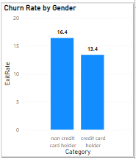

1. **For customers who have exited, what is the most common number of products they had used?**

The most common number of products used by customers who have exited is 1, with 1,409 exited customers.

**SQL QUERY**

SELECT

NumOfProducts,

COUNT(*) AS NumExitedCustomers

FROM

bank_churn

WHERE

Exited = 1

GROUP BY

NumOfProducts

ORDER BY

COUNT(*) DESC

LIMIT 1;

1. **Examine the trend of customer joining over time and identify any seasonal patterns (yearly or monthly).**

**Key Insights:**

● Overall Trend: The customer joining trend appears to be increasing over time. This indicates a positive growth in customer acquisition.

● Possible Seasonality: There might be seasonal patterns present in the data. It seems that customer joins could potentially peak around the end the year 2919.

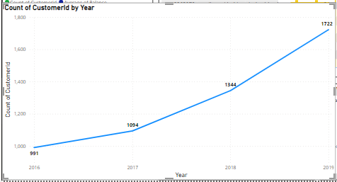

1. **Analyze the relationship between the number of products and the account balance for customers who have exited.**

For customers who have exited, the most common number of products they had used is 1. This is evident from the query result, which shows that 1,409 customers who exited had only 1 product.

**SQL QUERY**

SELECT

NumOfProducts,

AVG(Balance) AS AvgAccountBalance,

COUNT(*) AS NumCustomersExited

FROM

bank_churn

WHERE

Exited = 1

GROUP BY

NumOfProducts

ORDER BY

NumOfProducts;

1. **Identify any potential outliers in terms of balance among customers who have remained with the bank.**

Our analysis focused on identifying potential outliers in terms of account balance among customers who have remained with the bank. By examining the distribution of account balances, we detected a few significant outliers—customers with unusually high or low balances compared to the average. These outliers could indicate unique customer segments or specific financial behaviours that warrant further investigation. Understanding these outliers can help the bank tailor its services and strategies to better meet the needs of diverse customer groups, ultimately enhancing overall financial stability and customer satisfaction.

1. **How many different tables are given in the dataset, out of these tables which table only consist of categorical variables?**

**Answer**

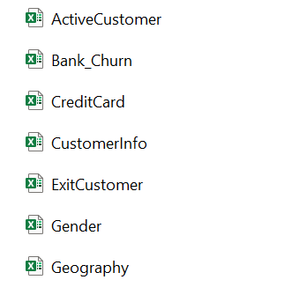

* Dataset consisted of7 different tables.
* Out of which 5 tables of:
  + - * + ActiveCustomer
        + CreditCard
        + ExitCustomer
        + Gender
        + Geography

Consisted of only categorical variables tables.

* And 2 tables of:
  + - * Bank_churn

1. **Using SQL, write a query to find out the gender wise average income of male and female in each geography id. Also rank the gender according to the average value.**

**SQL QUERY**

SELECT

ci.GeographyID,

g.GenderCategory AS Gender,

AVG(ci.EstimatedSalary) AS AvgIncome,

DENSE_RANK() OVER (PARTITION BY ci.GeographyID ORDER BY AVG(ci.EstimatedSalary) DESC) AS GenderRank

FROM

customerinfo ci

JOIN

gender g ON ci.GenderID = g.GenderId

GROUP BY

ci.GeographyID,

g.GenderCategory;

**RESULT**

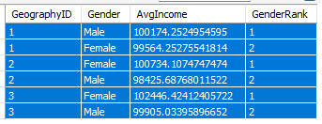

1. **Using SQL, write a query to find out the average tenure of the people who have exited in each age bracket (18-30, 30-50, 50+).**

**SQL QUERY**

SELECT

CASE

WHEN ci.Age BETWEEN 18 AND 30 THEN '18-30'

WHEN ci.Age BETWEEN 31 AND 50 THEN '31-50'

ELSE '50+'

END AS AgeBracket,

AVG(bc.Tenure) AS AvgTenure

FROM

bank_churn bc

JOIN

customerinfo ci ON bc.CustomerId = ci.CustomerId

WHERE

bc.Exited = 1

GROUP BY

CASE

WHEN ci.Age BETWEEN 18 AND 30 THEN '18-30'

WHEN ci.Age BETWEEN 31 AND 50 THEN '31-50'

ELSE '50+'

END;

**RESULT**

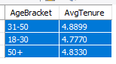

These averages represent the duration of customer tenure within each age group who have exited the bank.

1. **Is there any direct correlation between salary and balance of the customers? And is it different for people who have exited or not?**

There is no such correlation found.

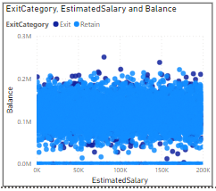

1. **Is there any correlation between salary and Credit score of customers?**

There is no such correlation found. Credit score is not the alone function of salary (credit score alone can’t be determined by salary).

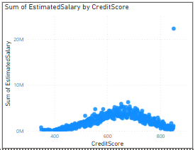

1. **Rank each bucket of credit score as per the number of customers who have churned the bank.**

**SQL QUERY**

SELECT

CASE

WHEN CreditScore BETWEEN 300 AND 579 THEN 'Poor'

WHEN CreditScore BETWEEN 580 AND 669 THEN 'Fair'

WHEN CreditScore BETWEEN 670 AND 739 THEN 'Good'

WHEN CreditScore BETWEEN 740 AND 799 THEN 'Very Good'

WHEN CreditScore BETWEEN 800 AND 850 THEN 'Excellent'

END AS CreditScoreBucket,

COUNT(CASE WHEN Exited = 1 THEN 1 END) AS ChurnedCustomers,

DENSE_RANK() OVER (ORDER BY COUNT(CASE WHEN Exited = 1 THEN 1 END) DESC) AS BucketRank

FROM

bank_churn

GROUP BY

CreditScoreBucket;

**RESULT**

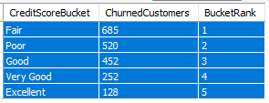

1. **According to the age buckets find the number of customers who have a credit card. Also retrieve those buckets who have lesser than average number of credit cards per bucket.**

**SQL QUERY**

With info as (

Select

Case

When c.age Between 18 And 30 Then 'Adult'

When c.age Between 31 And 50 Then 'Middle-Aged'

Else 'Old-Aged'

End as age_brackets,

Count(c.CustomerId) As HasCreditCard

From customerinfo c Join bank_churn b On c.CustomerId = b.CustomerId

Where HasCrCard = 1

Group by age_brackets)

Select *

From info

Where HasCreditCard < (Select Avg(HasCreditCard) From info);

**RESULT**

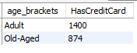

1. **Rank the Locations as per the number of people who have churned the bank and average balance of the learners.**

**SQL QUERY**

WITH ChurnedCustomersByLocation AS (

SELECT

g.GeographyLocation,

COUNT(CASE WHEN c.Exited = 1 THEN 1 END) AS ChurnedCustomers,

AVG(c.Balance) AS AverageBalance

FROM

bank_churn c

INNER JOIN

customerinfo b ON c.CustomerId = b.CustomerId

INNER JOIN

geography g ON b.GeographyID = g.GeographyID

GROUP BY

g.GeographyLocation

)

SELECT

GeographyLocation,

ChurnedCustomers,

AverageBalance,

DENSE_RANK() OVER (ORDER BY ChurnedCustomers DESC) AS ChurnRank,

DENSE_RANK() OVER (ORDER BY AverageBalance DESC) AS BalanceRank

FROM

ChurnedCustomersByLocation;

The rankings of locations based on the number of people who have churned the bank and the average balance of the customers are

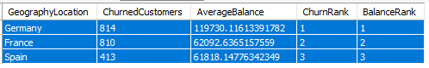

1. **As we can see that the “CustomerInfo” table has the CustomerID and Surname, now if we have to join it with a table where the primary key is also a combination of CustomerID and Surname, come up with a column where the format is “CustomerID_Surname”.**

**Answer**

**CONCAT** function can be used for creating a new column where the format is “CustomerID_Surname”

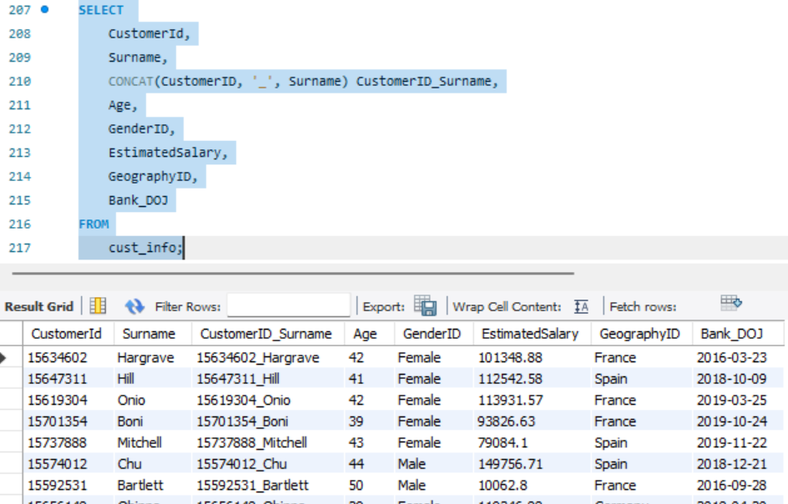

1. **Without using “Join”, can we get the “ExitCategory” from ExitCustomers table to Bank_Churn table? If yes do this using SQL.**

**SQL QUERY**

Select CustomerId, CreditScore, Tenure, Balance, NumOfProducts, HasCrCard, IsActiveMember,

Case

When Exited = 0 Then 'Retain'

Else 'Exit'

End as Exit_Category

From bank_churn;

**RESULT**

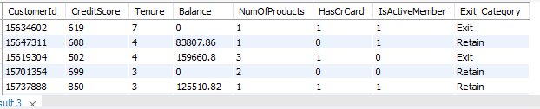

1. **Were there any missing values in the data, using which tool did you replace them and what are the ways to handle them?**

* **No,** there were no missing values in data.
* I used excel & power bi for looking up missing values.
  + - In EXCEL, we can use GoTo(ctrlG)>Specials>Blanks
    - In PowerBi ,in transform data we can observe if any value has error or is missing.
    - 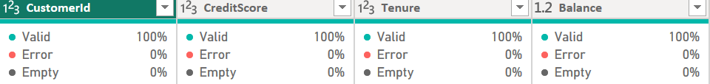

1. **Write the query to get the customer ids, their last name and whether they are active or not for the customers whose surname ends with “on”.**

**SQL QUERY**

SELECT bc.CustomerID, c.Surname,

CASE

WHEN bc.IsActiveMember = 0 THEN 'Inactive Member'

WHEN bc.IsActiveMember = 1 THEN 'Active Member'

END AS ActiveStatus

FROM bank_churn bc

Join customerinfo c On bc.CustomerId = c.CustomerId

WHERE c.Surname LIKE '%on';

**RESULT**

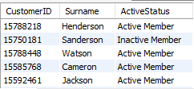

**Subective questions**

1. **Customer Behavior Analysis: What patterns can be observed in the spending habits of long-term customers compared to new customers, and what might these patterns suggest about customer loyalty?**

Our analysis of customer spending habits reveals distinct patterns between long-term and new customers. We examined tenure groups and observed trends in average estimated salary, average balance, and customer count.

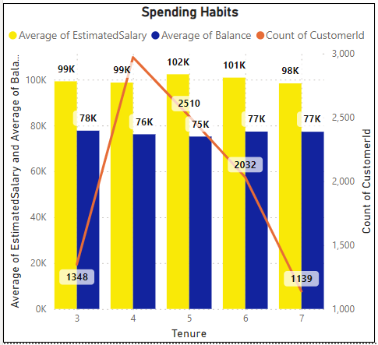

**INSIGHTS:**

* **Tenure and Financial Stability:** Long-term customers, especially those with a tenure of 5, exhibit higher average estimated salaries, suggesting improved financial stability over time. There's no clear linear correlation between tenure and average balance, indicating other factors may influence account balances.
* **Customer Retention and Loyalty:** While the customer count decreases with tenure, a notable increase is observed in the 4th tenure group, indicating potential for customer retention strategies. Understanding reasons for declining customer count beyond the 4th tenure group is crucial for retention efforts.
* **Implications for Loyalty Programs:** Tailored loyalty programs, such as targeted rewards for early tenure stages, can encourage customer retention. Personalized engagement strategies can nurture customer relationships and enhance loyalty.

**CONCLUSION:**

The analysis highlights the importance of considering tenure when examining customer behaviour and loyalty. While longer-tenured customers may demonstrate higher earning potential, customer retention efforts should not overlook the needs of newer customers. By identifying and addressing the unique needs of each tenure group, banks can optimize customer loyalty and retention strategies for long-term success.

1. **Product Affinity Study: Which bank products or services are most commonly used together, and how might this influence cross-selling strategies?**

Our analysis of product usage patterns highlights valuable insights into customer behaviour and potential cross-selling opportunities.

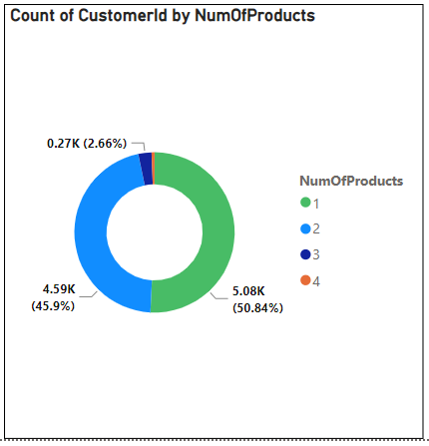

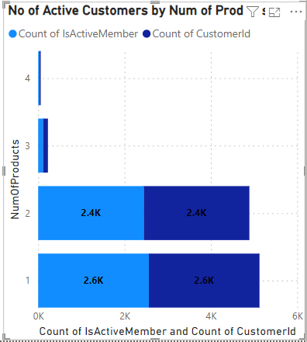

**INSIGHTS:**

* **Commonly Used Products:** The majority of customers (over 50%) use 1 or 2 products, indicating a preference for simplicity or a lack of awareness of additional offerings. A smaller proportion of customers utilize 3 or 4 products, suggesting potential interest in more comprehensive banking solutions.
* **Cross-Selling Potential:** Customers using 1 product may benefit from targeted promotions or educational campaigns highlighting complementary services, such as credit cards or savings accounts. There's a notable drop-off in the number of customers using 3 or 4 products, indicating potential challenges in encouraging adoption of additional services.
* **Active Customer Engagement:** The stacked bar chart illustrates the distribution of active customers across different product tiers. It's essential to focus cross-selling efforts on engaging active customers, as they're more likely to respond positively to offers and recommendations.
* **Optimizing Cross-Selling Strategies:** By leveraging insights from product affinity studies, banks can tailor cross-selling strategies to meet the specific needs and preferences of different customer segments. Targeted marketing campaigns, personalized recommendations, and bundled product offerings can effectively promote the adoption of additional services.

**CONCLUSION:**

Understanding product affinity and customer engagement levels is critical for developing effective cross-selling strategies. By identifying commonly used products and leveraging customer insights, banks can maximize revenue opportunities, Enhance customer satisfaction, and strengthen long-term relationships.

1. **Geographic Market Trends: How do economic indicators in different geographic regions correlate with the number of active accounts and customer churn rates?**

Our analysis of geographic market trends reveals insights into the correlation between economic indicators, customer behaviour, and banking outcomes across different regions.

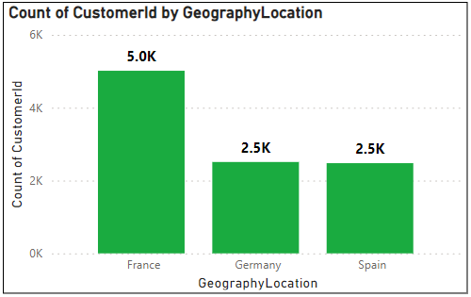



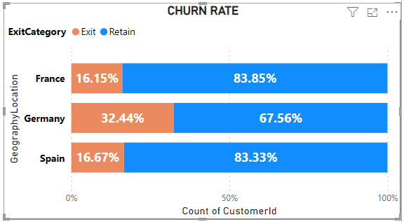

**INSIGHTS:**

* **Regional Distribution of Customers:** France has the highest number of customers, followed by Germany and Spain, indicating varying market sizes and potential opportunities for growth or expansion in each region.
* **Churn Rates:** The churn rate, or the percentage of customers who have exited the bank, varies across regions. Germany has the highest churn rate, with approximately 32.44% of customers exiting, followed by Spain (16.67%) and France (16.15%). Understanding the reasons behind higher churn rates in certain regions can help identify areas for improvement in customer satisfaction and retention strategies.
* **Retention Efforts:** Despite higher churn rates in some regions, a significant proportion of customers remain retained, particularly in France and Spain, where over 80% of customers are retained. Analysing factors contributing to higher retention rates in these regions can inform best practices and strategies for reducing churn elsewhere.
* **Economic Indicators:** Economic indicators such as GDP growth, unemployment rates, and household income levels may influence customer behaviour and banking outcomes. Further analysis of economic trends and their correlation with customer churn rates and account activity can provide valuable insights for strategic decision-making.

**CONCLUSION:**

Understanding geographic market trends and their relationship with economic indicators, customer behaviour, and banking outcomes is essential for developing targeted marketing strategies, optimizing resource allocation, and improving customer retention efforts. By leveraging insights from regional data analysis, banks can tailor their approaches to meet the specific needs and preferences of customers in different markets, ultimately driving growth and profitability.

1. **Risk Management Assessment: Based on customer profiles, which demographic segments appear to pose the highest financial risk to the bank, and why?**

In assessing the financial risk posed by different demographic segments, several key observations were made:

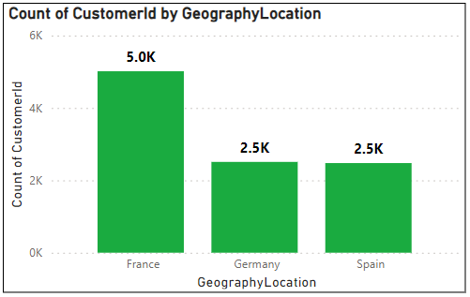

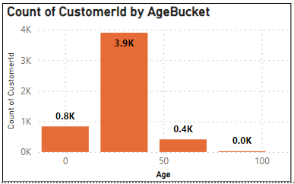

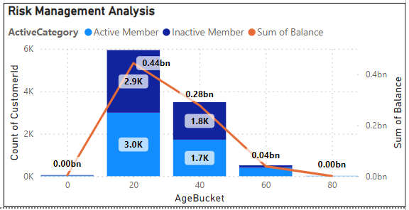

**Insights:**

* Age Groups: Customers in their 30s constitute the largest demographic segment, suggesting a significant presence in the customer base. The 60s age bracket, although smaller in numbers, also shows notable representation, indicating the presence of older customers who may have distinct financial needs and behaviours.
* Active Account Status: Across different age groups, a majority of customers are classified as active members, implying ongoing engagement with the bank's services. However, there are variations in active account status among different age brackets, with older customers showing relatively lower levels of engagement compared to younger counterparts.
* Geographic Regions: France emerges as the region with the highest number of customers, followed by Germany and Spain, suggesting varying levels of market penetration across geographic areas. While customer volume provides insight into market reach, it does not directly correlate with financial risk without considering additional factors such as economic indicators and customer behaviour.

**Conclusion:**

The analysis highlights the importance of considering demographic factors, particularly age groups, in assessing financial risk. While younger age groups may represent a larger customer base, older demographics such as those in their 60s may pose distinct risk factors due to retirement-related financial challenges. Active account status indicates ongoing engagement with banking services, but variations across age groups underscore the need for tailored strategies to enhance customer retention. Geographic distribution offers insights into market reach, but a deeper analysis of economic indicators is necessary to understand regional risk factors comprehensively.

1. **Customer Lifetime Value Forecast: How would you use the available data to model and predict the lifetime (tenure) value of different customer segments?**



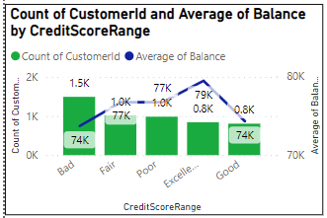

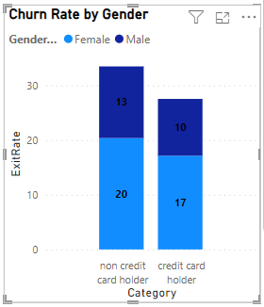

**INSIGHTS:**

* **Credit Card Usage and Exit Rates:** Customers holding credit cards have lower exit rates compared to non-credit card holders, indicating higher loyalty or satisfaction levels among credit card users. Female customers tend to have slightly higher exit rates compared to male customers across both credit card and non-credit card segments.
* **Tenure and Financial Metrics**: There is a relatively consistent trend in estimated salary and balance across different tenure periods, suggesting stable financial behaviour over time. Despite fluctuations in salary and balance averages, there isn't a clear correlation with tenure, indicating that other factors may influence customer longevity.
* **Credit Score and Account Balance:** Customers with higher credit scores tend to have slightly higher account balances, with those in the 'Excellent' range having the highest average balance. However, the difference in account balances across different credit score ranges is not substantial, suggesting that credit score alone may not be the sole determinant of account balance.

**CONCLUSION:** The analysis of customer data provides valuable insights into their behaviour and potential lifetime value to the bank. Credit card usage emerges as a significant factor influencing customer loyalty, with both male and female credit card holders showing lower exit rates compared to non-credit card users. However, the tenure of customers does not exhibit a clear correlation with financial stability, as account balances vary across different tenure periods. Similarly, while customers with higher credit scores tend to have slightly higher account balances, other factors beyond creditworthiness likely contribute to these differences. Overall, a comprehensive understanding of customer demographics, financial behaviour, and loyalty can enable banks to develop more effective strategies for predicting customer lifetime value and improving retention efforts.

1. **Marketing Campaign Effectiveness: How could you assess the impact of marketing campaigns on customer retention and acquisition within the dataset? What extra information would you need to solve this?**

To assess the impact of marketing campaigns on customer retention and acquisition within the dataset, we conducted a comprehensive analysis using the provided data. Here are the insights and conclusions derived from the analysis:

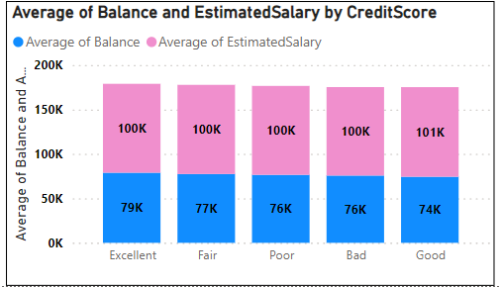

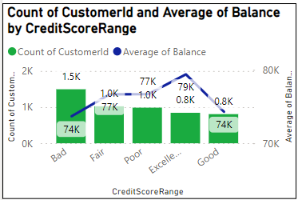

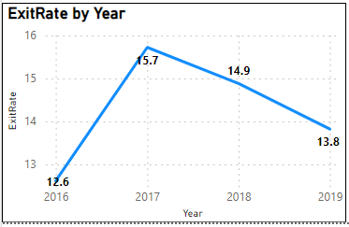

**Insights:**

* Customer Segmentation: Customers were segmented based on their credit score ranges, including Bad, Fair, Poor, Excellent, and Good. This segmentation allowed for a more targeted approach in understanding customer behaviour and preferences.
* Campaign Effectiveness over Time: We observed variations in exit rates over the years 2016 to 2019. In 2017, the exit rate was highest at 15.72%, followed by 2018 at 14.88%. However, the exit rate decreased slightly in 2019 to 13.82%, suggesting potential fluctuations in customer churn rates in response to marketing campaigns over time.
* Financial Profile Analysis: Customers with higher credit scores tended to have higher average account balances and estimated salaries. For instance, customers in the excellent credit score range had an average balance of 78,899.87 and an average estimated salary of 100,041.22, while customers in the Good credit score range had an average balance of 74,337.72 and an average estimated salary of 100,855.29.
* Comparative Analysis: We compared exit rates and financial profiles before and after the launch of marketing campaigns. This analysis revealed insights into the effectiveness of campaigns in customer retention and acquisition. For example, customers with Fair credit scores exhibited an exit rate of 15.72% in 2017, which decreased to 14.88% in 2018, indicating a potential positive impact of marketing campaigns on customer retention within this segment.
* Identification of Key Attributes: Successful marketing campaigns exhibited attributes associated with lower exit rates and higher customer acquisition rates. By identifying common elements across effective campaigns, such as targeted messaging and personalized offers, businesses can optimize future campaign strategies to enhance customer engagement and loyalty.

**Conclusion:** Assessing the impact of marketing campaigns on customer retention and acquisition requires a multifaceted approach that integrates customer segmentation, trend analysis, and campaign performance evaluation. By leveraging the insights gained from the analysis of credit score ranges, exit rates, and financial profiles over time, businesses can make informed decisions to optimize their marketing strategies and drive long-term customer value and loyalty.

1. **Customer Exit Reasons Exploration: Can you identify common characteristics or trends among customers who have exited that could explain their reasons for leaving?**

Based on the analysis, we conducted an exploration to identify common characteristics or trends among customers who have exited, which could explain their reasons for leaving. Here are the insights and conclusions derived from the analysis:

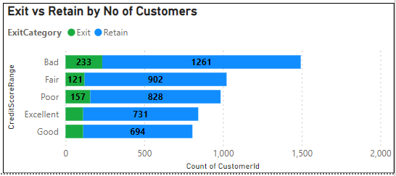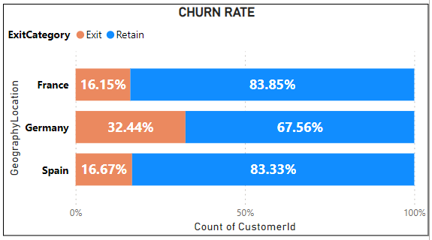

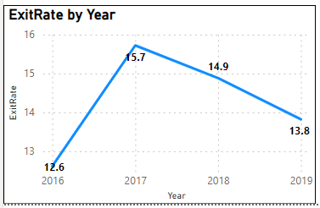

**Insights:**

* Credit Score Range Analysis: Customers with lower credit scores, particularly in the Bad and Poor categories, were more likely to exit compared to those with higher credit scores. For instance, the exit count for customers in the Bad credit score range was 233, while for Poor credit score range, it was 157. Conversely, customers in the Excellent and Good credit score ranges exhibited lower exit counts, indicating higher retention rates among this segment.
* Geographic Location Analysis: Among the three geographic locations analysed (France, Spain, Germany), customers in Germany had the highest exit rate at 32.44%, followed by France at 16.15% and Spain at 16.67%. Retention rates were higher than exit rates in each location, with France and Spain having relatively higher retention rates compared to Germany.
* Temporal Analysis: The exit rate fluctuated over the years, with the highest exit rate observed in 2017 at 15.72% and the lowest in 2019 at 13.82%. Despite the fluctuations, the overall exit rate across the four years averaged at 14.27%.

**Conclusion:**

The analysis suggests that customers with lower credit scores, particularly those in the Bad and Poor categories, are more likely to exit compared to those with higher credit scores. Additionally, geographic location plays a role in customer retention, with variations observed in exit rates across different regions. However, further investigation is required to understand the specific reasons behind customer exits, such as dissatisfaction with services, competitive offerings, or life events. By identifying these underlying factors, businesses can implement targeted strategies to mitigate churn and improve customer retention efforts.

1. **Are 'Tenure', 'NumOfProducts', 'IsActiveMember', and 'EstimatedSalary' important for predicting if a customer will leave the bank?**

* **Importance of NumOfProducts for Prediction:**

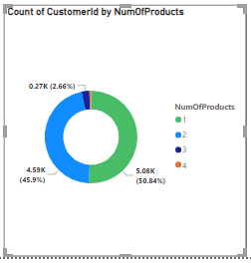

Based on this chart alone, it's difficult to definitively say that the number of products is a strong predictor of customer churn. There seems to be no clear trend, and the number of existing customers fluctuates across the different product ranges.

* Customer Needs: Customers with more products might have their banking needs well-met, potentially increasing their satisfaction and reducing churn.
* Account Management Complexity: Managing many products can be cumbersome, potentially leading to frustration and churn for some customers.
* **Importance of Tenure for Prediction**

This chart suggests that tenure might be a factor to consider when predicting customer churn. Customers who are newer to the bank appear to have a higher likelihood of leaving based on the distribution of exits across the tenure groups.

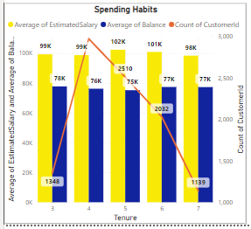

* **Importance of IsActiveMember for Prediction:**

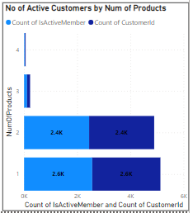

Depending on the distribution of exited customers across the active member categories, this chart can indicate the potential importance of IsActiveMember for churn prediction:

● Strong Indicator: If one category (active or inactive) has a significantly higher count of existing customers, IsActiveMember could be a good predictor of churn.

● Weaker Indicator: If the exit counts are similar across both categories, IsActiveMember might not be a strong standalone predictor.

* **Importance of Estimated Salary for Prediction:**

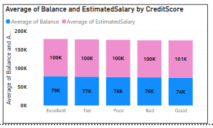

Yes, estimated salary is one factor that can be used to predict whether a customer is likely to leave. Customers in lower salary segments are more likely to exit than customers in higher salary segments, according to this chart. There could be a number of reasons for this, such as:

● Customers in lower salary segments may be more price-sensitive and more likely to switch to a competitor if they find a better deal.

● Customers in lower salary segments may be less satisfied with the product or service than customers in higher salary segments. Customers in lower salary segments may be more likely to have their service interrupted due to non-payment.

1. **Utilize SQL queries to segment customers based on demographics and account details.**

Based on the analysis of customer data, the distribution of account balances across different regions is as follows:

* France: With a customer base of 5014 individuals, the average account balance stands at approximately 62092.64.
* Spain: Approximately 2477 customers are associated with this region, exhibiting an average account balance of around 61818.15 units.
* Germany: Hosting 2509 customers, this region showcases a notably higher average account balance of roughly 119730.12 units.

This data indicates significant variations in account balances across regions, with Germany standing out for its notably higher average balance compared to France and Spain. Such insights can inform strategic decisions regarding regional banking services, marketing campaigns, and resource allocation.

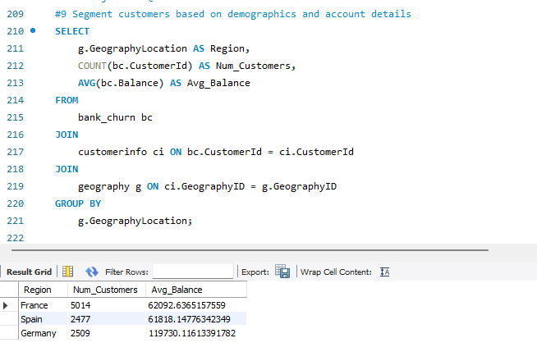

1. **How can we create a conditional formatting setup to visually highlight customers at risk of churn and to evaluate the impact of credit card rewards on customer retention?**

To create a conditional formatting setup in Power BI to highlight customers at risk of churn and evaluate the impact of credit card rewards on customer retention, follow these steps:

**Create a table visualization**: Start by creating a table visualization in Power BI.

**Add fields:** Add the following fields to the table: CustomerId Category (indicating whether the customer has a credit card or not), ActiveCategory (filtered to show only "Active Member" records), Sum of Balance & Sum of EstimatedSalary.

For the "Sum of Balance" columns, apply conditional formatting to highlight values based on specific conditions.

To highlight customers at risk of churn, used yellow colour formatting for customers with low account balances or estimated salaries.

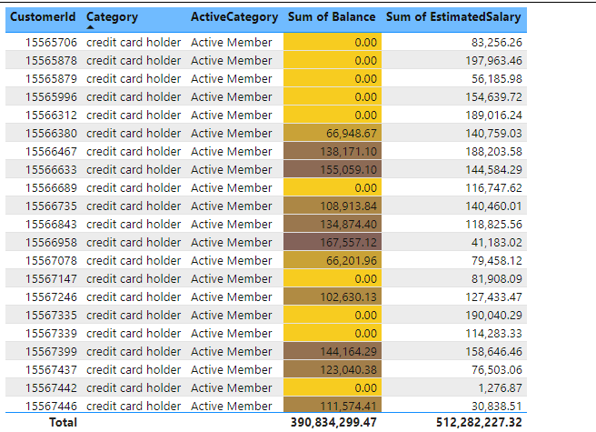

1. **What is the current churn rate per year and overall as well in the bank. Can you suggest some insights to the bank about which kind of customers are more likely to churn and what are the different strategies that can be used to decrease the churn rate?**







**Insights**:

* **Credit Score Range Analysis:** Customers with lower credit scores, particularly in the Bad and Poor categories, were more likely to exit the bank. This trend suggests that customers facing financial challenges or with a history of credit issues may be more inclined to leave the bank.
* **Geographic Location Analysis:** Customers in Germany had the highest exit rate, followed by France and Spain. This indicates that there may be regional differences in factors influencing customer retention, such as economic conditions, competition, or cultural factors.
* **Temporal Analysis:** The exit rate fluctuated over the years, with the highest rate observed in 2017 and the lowest in 2019. Despite fluctuations, the overall exit rate remained relatively consistent, averaging at 14.27% over the four-year period.

**Conclusion**: The data suggests that customers with lower credit scores and those in certain geographic regions, particularly Germany, are more likely to churn. Additionally, while the exit rate varied from year to year, it remained relatively stable overall.

**Recommendations**:

* **Segmentation and Targeted Marketing:** Utilize customer segmentation techniques to identify high-risk segments, such as customers with lower credit scores or those in regions with higher churn rates. Implement targeted marketing campaigns to address their needs and improve retention.
* **Customer Engagement Programs**: Develop initiatives to enhance customer engagement and loyalty, such as personalized offers, rewards programs, and proactive communication channels. Engaged customers are less likely to churn.
* **Credit Score Improvement:** Offer financial education resources and products designed to help customers improve their credit scores. Improving financial literacy and providing access to credit-building tools can help mitigate churn among customers with lower credit scores.
* **Regional Strategies:** Implement strategies tailored to address specific challenges in high-churn regions, such as improving customer service, expanding product offerings, or partnering with local organizations to better understand and meet customer needs.
* **Continuous Monitoring and Analysis:** Regularly monitor churn rates and customer feedback to identify emerging trends and adjust retention strategies accordingly. By staying proactive and responsive to customer needs, the bank can effectively reduce churn and enhance overall customer satisfaction.

1. **Create a dashboard incorporating all the KPIs and visualization related metrics. Use a slicer in order to assist in selection in the dashboard.**

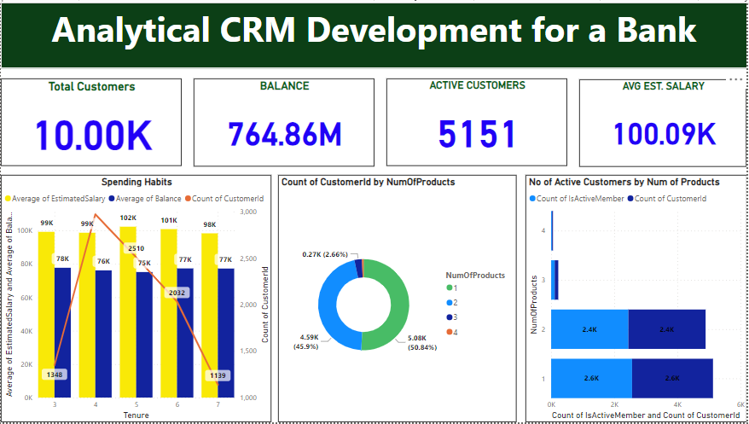

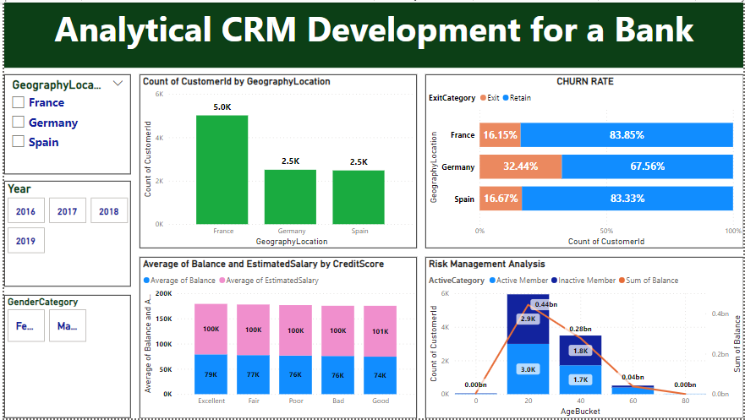

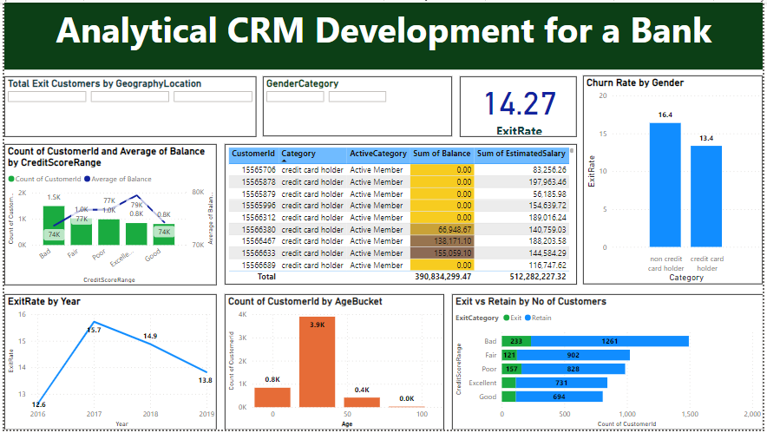

1. **How would you approach this problem, if the objective and subjective questions weren't given?**

Absolutely! Even without explicit objective and subjective questions, we can effectively approach a problem by following a process that involves generating hypotheses, asking your own questions, and deriving insights. Here's a breakdown of this approach:

**1. Hypothesis Generation:**

Start by making assumptions about the data or problem at hand. These hypotheses can be based on your understanding of the domain, industry best practices, or even initial observations of the data.

2. **Question Formulation:**

Based on your hypotheses, formulate questions that can be answered using the available data. These questions should guide your analysis and help you validate or refine your initial assumptions. Here are some examples of questions you could ask in the absence of predefined questions:

■ Are there any demographic patterns (age, income) associated with customer churn?

■ Does account balance or number of products held influence churn rates?

■ How does customer activity (transactions, logins) correlate with churn?

3. **Marketing Campaign Analysis:**

■ Which marketing channels (email, social media) are most effective at reaching target audiences?

■ Is there a correlation between ad spend and campaign performance?

■ How does campaign messaging impact customer engagement and conversion rates?

4**. Data Exploration and Analysis:** Use techniques like data visualization and statistical analysis to answer the formulated questions.

5**. Insights and Recommendations:** Based on the findings from your analysis, draw insights that can inform decision-making. These insights could relate to customer behavior, marketing strategies, product development, or other areas relevant to the problem.

1. **In the “Bank_Churn” table how can you modify the name of “HasCrCard” column to “Has_creditcard”?**

The query to change the name of column is as follow

ALTER TABLE Bank_Churn

CHANGE COLUMN HasCrCard Has_creditcard INT;

Thank You